ipynb file and csv file in local drive.

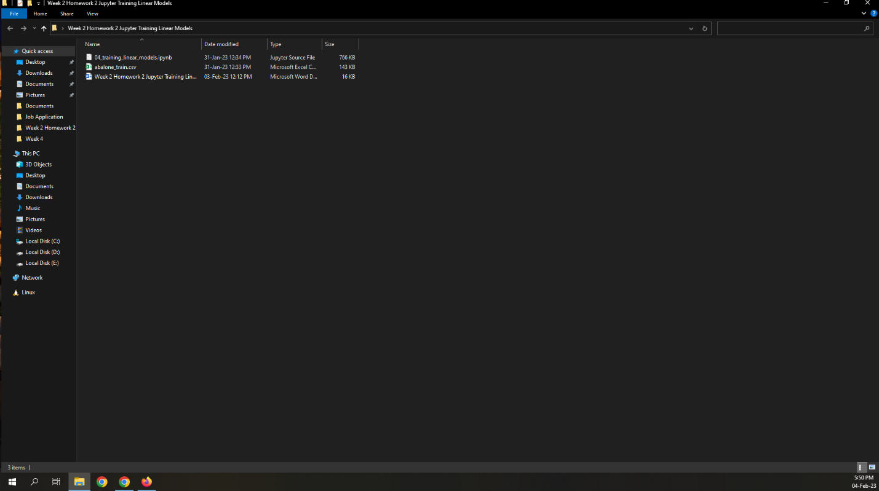

Importing ipynb file to Google Collab.

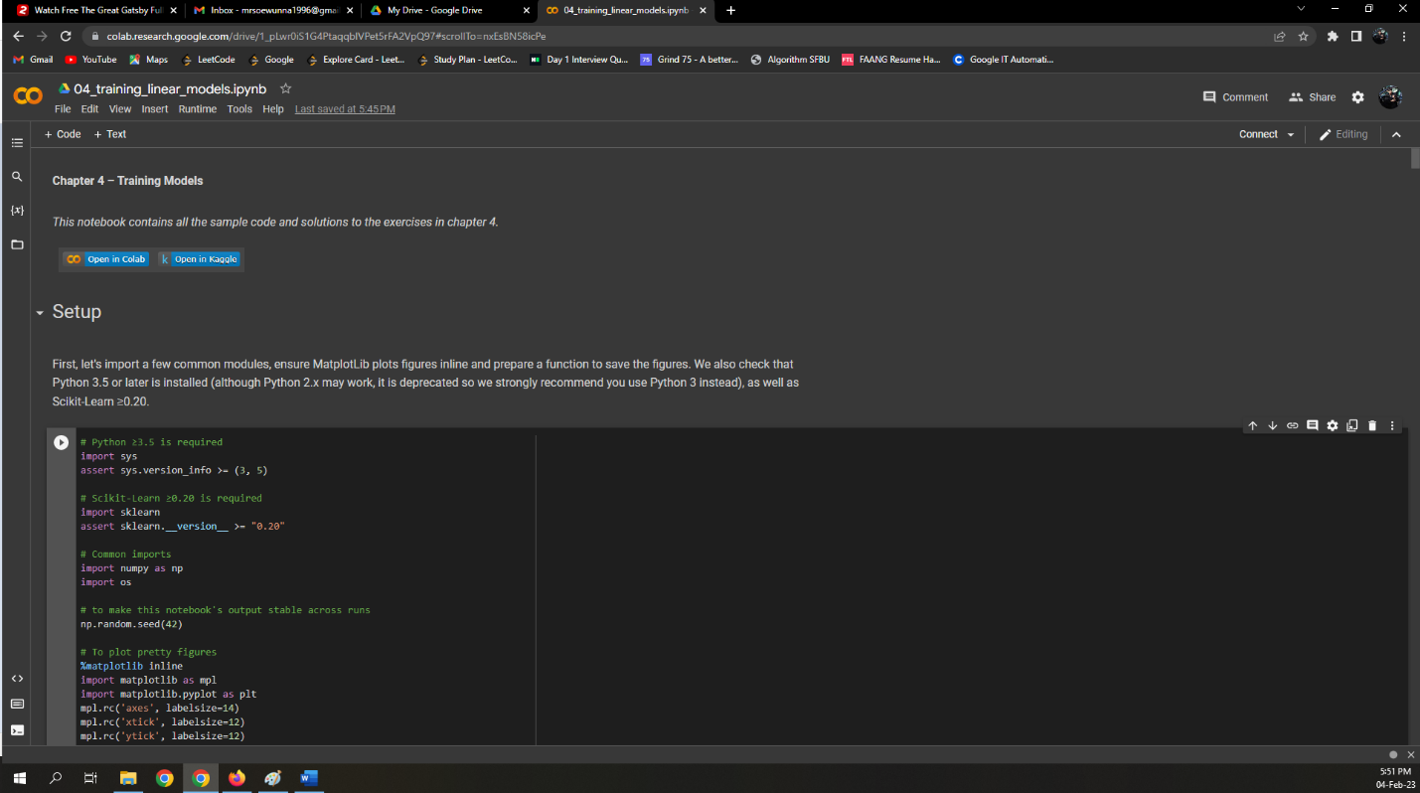

Modifying the 2 lines of code.

Reading data from a local drive and transform the data to fit the Python code.

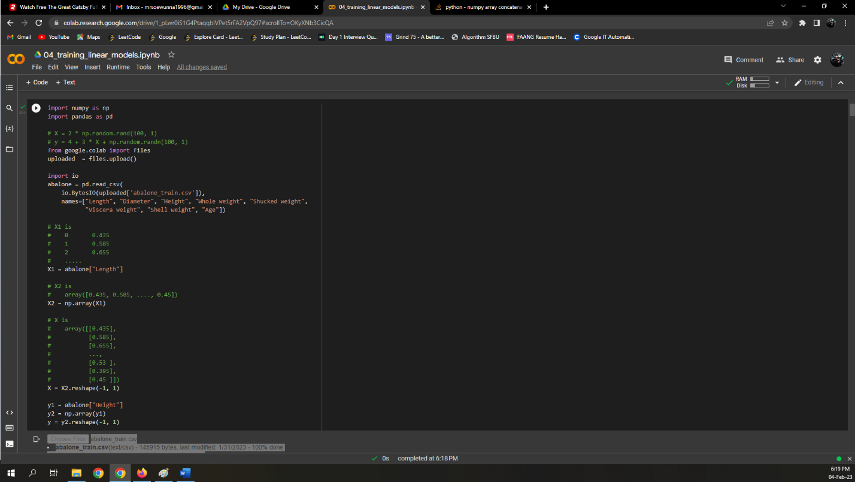

Choose the file to upload.

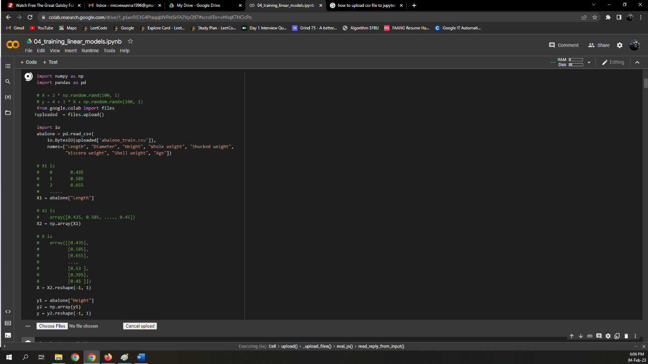

csv file is uploaded.

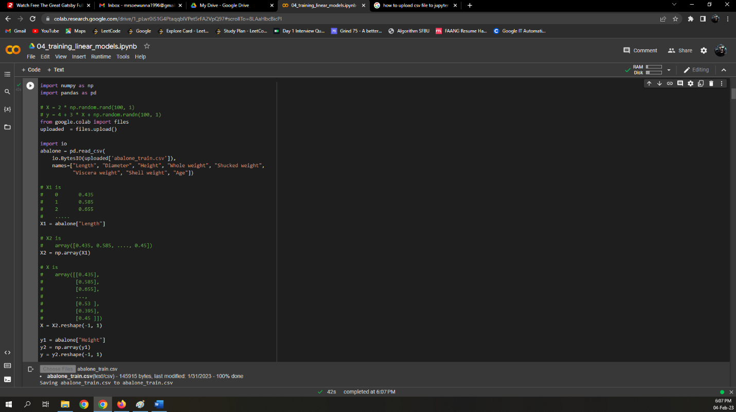

Changing 100 to 3320 and the problem has been solved.

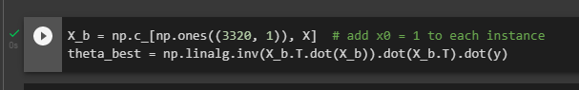

Or

We need to define nrows = 100.

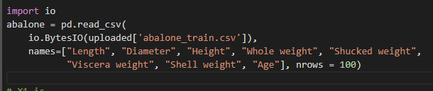

Running all blocks of code.

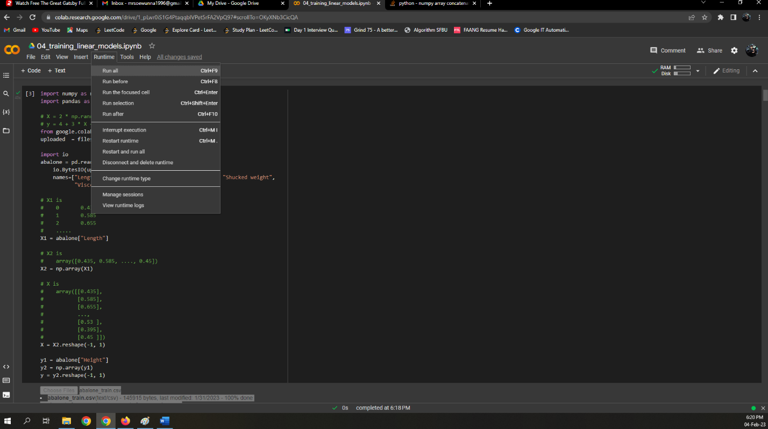

The entire notebook has run successfully.

